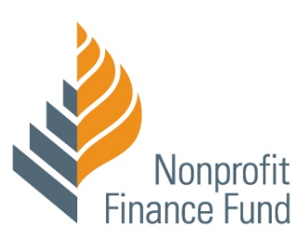

WORKSHEET
NFF Webinar: Operating In a Changing World, Part 1

#1 Assess Our Complete Strengths
 | Strengths  What complete capital areas are well resourced? | Opportunities or Risks  What strengths could be leveraged to fill areas of needs or gaps in resources?
Financial
Relationships & Reputation
People & Skills
Data & Know-How

#2 Strategies for Navigating Inequitable System

- How do these dynamics show up for your organization? For the field?

- How are you already navigating these challenges? What is working well, what’s not?

- What do you need?

#4 Balancing Mission & Money: Portfolio of Activities: Plot each major program or activity that your organization operates on this grid. What are the management and financial implications? What is affirming or surprising?
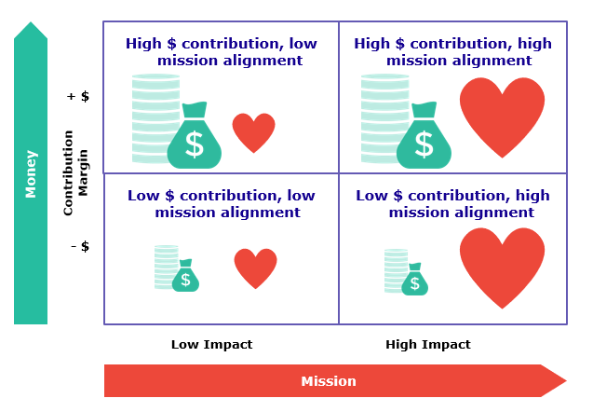

#5 Identifying Risk & Opportunity in the Budget
Revenue Dynamics

- What might shift in gov’t support and contracts? In individual donations?
- How might private funding shift away from some mission areas toward others?
- How are shifting markets affecting our earned revenue?
- What is already secured/guaranteed or not?

Expense Dynamics

- Increased demand? Decreased demand?
- New partnerships or funding opportunities that require staff time and financial resources?
- Staff or expenses contingent on securing funding that’s now uncertain?
- Changes to rent? Can we renegotiate?

Profitability & Savings

- How well can we tolerate a deficit due to what’s at risk or the cost of opportunity?
- Any opportunities to generate savings?

