September 14, 2026

Her Excellency Maura Healey
Governor of the Commonwealth of Massachusetts

The Honorable Kim Driscoll
Lt. Governor of the Commonwealth of Massachusetts

The Honorable Andrea Campbell
Attorney General of the Commonwealth of Massachusetts

The Honorable Karen Spilka
President of the Massachusetts Senate

The Honorable Ronald Mariano
Speaker of the Massachusetts House of Representatives

Delivered via email.

Re: Creative Youth Development (CYD), After and Out-of-School Youth Arts Programming, and the Massachusetts Meta Settlement

Dear Madame Governor, Lt. Governor, Attorney General, President, and Mr. Speaker:

On behalf of the governing Council and staff of Mass Cultural Council, your state arts agency, I am writing to inquire about the process by which the Meta settlement funds will be distributed, to note that Massachusetts families benefit from after and out-of-school youth arts programming in every corner of the Commonwealth, and to submit for your consideration that Mass Cultural Council hopes to partner with you to ensure these impactful programs are included as a plan for these monies is developed.

Further, I wish to share information about Massachusetts’ Creative Youth Development (CYD) field and to strongly encourage that some of those resources be made available to support CYD. Massachusetts has one of the most established CYD ecosystems in the nation, with more than 100 programs that have been supported by the Commonwealth over the last three decades.

My understanding is that the settlement provides Massachusetts with up to $516 million, including approximately $366 million guaranteed over ten years. According to the Attorney General’s Office, the funds are intended in part to remediate harms caused by social media to Massachusetts young people, including through youth crisis intervention and mental health services; after-school, summer, and outdoor programs; digital wellness and literacy; phone-free school initiatives; and training for medical providers on interactive media use and body dysmorphia.

Creative Youth Development is a nationally recognized field of practice infusing intentional positive youth development practices with high quality, in person experiences in the arts, humanities, and interpretative sciences, centering youth voices, meaningful relationships, and leadership development. CYD prioritizes youth development, creative engagement, community connection, workforce development, and social-emotional wellbeing. By employing the arts, humanities, and sciences these programs provide young people opportunities to create, lead, collaborate, build relationships, and contribute to their communities. Instead of treating youth as problems to fix, CYD views young people as community resources and active partners.
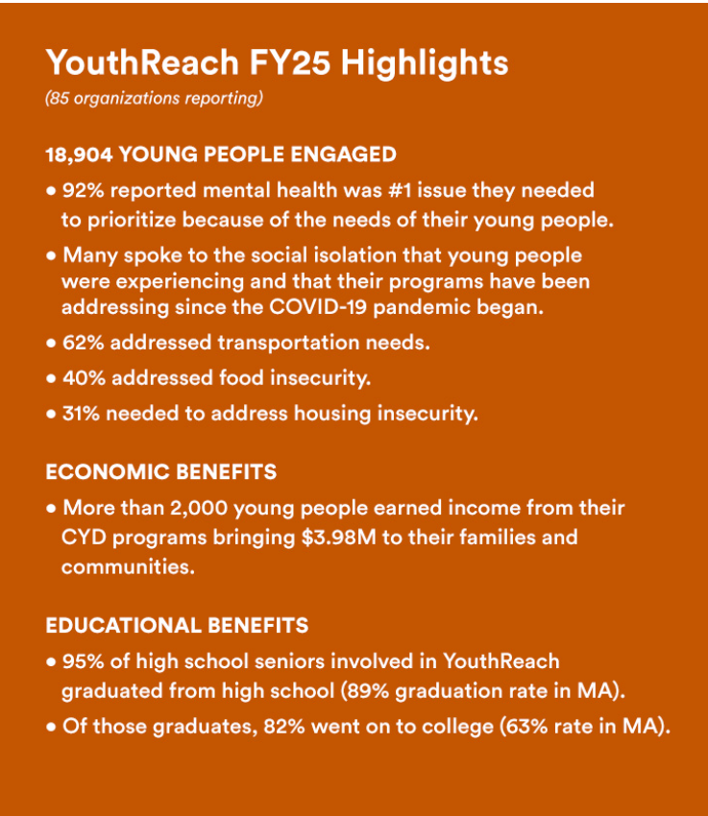
Mass Cultural Council has more than three decades of experience supporting this work through YouthReach, the longest continually running public funding program for Creative Youth Development in the United States.

Established in 1994, YouthReach has invested more than $26 million in 188 organizations over its history. In FY26, the program provided $1.84 million to 74 CYD programs across the Commonwealth. We are proud to note that collectively, over the life of the program, our grantee organizations have won more national awards from the President’s Committee on the Arts and Humanities than any other state in the nation for their dedicated efforts and programming.

The scale and reach of this existing infrastructure are significant. Our 85 YouthReach grant recipients reported that in FY24 18,904 young people across the Commonwealth participated in their programs. Eighty-five percent of these participants were Black, Indigenous, or people of color; 16 percent lived in homes where English was not the primary language; 11 percent were young people with disabilities; and 4 percent were engaged in services from the state’s Department of Mental Health.

YouthReach programs also demonstrate connections to economic and educational outcomes. In the most recent data, 2,038 young people earned income through their CYD organizations, generating $3.98 million in income for young people and their families and communities. Ninety-five percent of high school seniors participating in YouthReach programs graduated from high school, compared with an 89 percent Massachusetts average reported in the program’s analysis; 82 percent of those graduates went on to college or a trade school, compared with 64 percent of Massachusetts graduates enrolling in higher education. These figures are descriptive of YouthReach participants and have been consistent over time.

The programs provide a particularly relevant alternative to passive or excessive screen engagement, making them ideal for META settlement support. CYD programs are fundamentally participatory: young people make music, theater, visual art, poetry, films, scientific discoveries, and other creative work; work alongside teaching artists and peers; take on leadership roles; and engage with their communities.

During the COVID-19 pandemic, our CYD organizations demonstrated an ability to adapt their programming while maintaining relationships with young people and addressing mental health and other basic needs. During that time, YouthReach organizations became centers of trust in their communities for behavioral health and mental health referrals. This need for support continues, as in FY26, 85 percent of 74 CYD programs in Massachusetts identified mental health as a top concern for program administrators. The programs work to address this concern by hiring social workers, art therapists, and other professionals who provide trauma-informed training, one-on-one counseling sessions, and peer support groups to address mental health needs of their youth.

Mass Cultural Council has also invested in developing stronger approaches to measuring CYD outcomes and designing for collective impact through partnerships with practitioners, young people, and organizations including EdVestors, the Youth Arts Impact Network, and the 3C Data Alliance. The Council has helped develop shared indicators around outcomes such as creating, connecting, and catalyzing, all while centering youth voice, racial, and social equity, and collective action.

As Massachusetts considers how best to deploy the Meta settlement resources in the coming weeks and months, be aware that Creative Youth Development is an existing, statewide infrastructure with demonstrated reach, established public funding mechanisms, and experience serving young people through sustained creative and community-based engagement that should be prioritized. CYD is not an emerging infrastructure that would need to be created from scratch but a proven effective practice in need of greater funding.

Mass Cultural Council has established relationships, grant-management systems, application and reporting processes, and a statewide network of CYD organizations. YouthReach recipients submit annual reports documenting programmatic progress and financial information, providing an existing framework for public accountability and evaluation.

As physician and former U. S. Surgeon General Dr. Vivek Murthy famously said in 2024, “Loneliness is something we can do something about, and the arts play an important part of the solution.”

I hope you will give this data due consideration and know that Mass Cultural Council is available to answer any questions you might have. Do not hesitate to contact me, or Senior Director of Public Affairs Bethann Steiner, for additional information, and we would welcome a meeting with you or your teams to discuss this matter further at your convenience.

Sincerely,
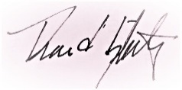
David T. Slatery
Acting Executive Director

cc: SWM Chair Rodrigues, HWM Chair Michlewitz, TACD Chairs Mark & Garballey

