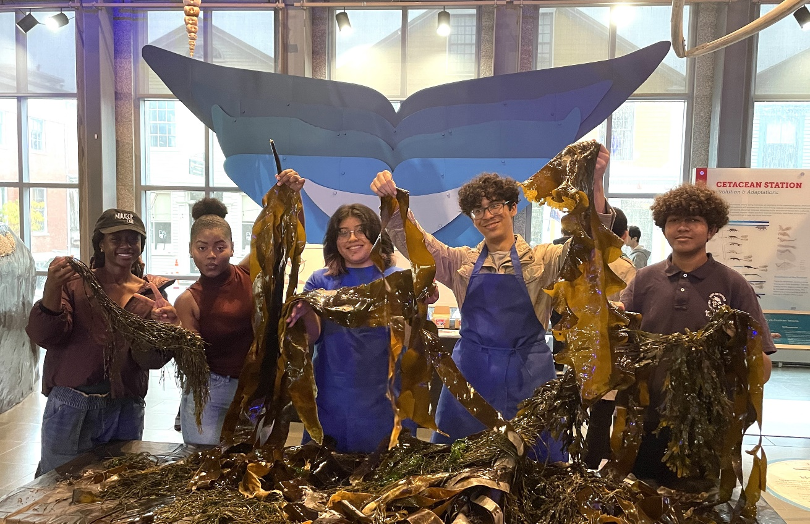Create, Connect, Catalyze: YouthReach in FY24

New Bedford Whaling Museum High School Apprentices participating in a Seaweed public program in partnership with the World Wildlife Fund. Photo: Samantha Santos.

*“Every Apprentice I met through my time here I created a strong connection with. These connections created laughter, cries, and smiles. These are people I will treasure, trust, and appreciate for a very long time. And I’ve been able to show my creativity throughout these years. Making an exhibit and having my own piece of art hanging on the wall for the public to see is honestly one of my best accomplishments.”* - Senior Apprentice, **New Bedford Whaling Museum**

## Table of Contents

Table of Contents 2

Introduction 2

FY24 YouthReach Participant Demographic Information 3

Gender 4

High School Seniors & Alums of CYD 4

Race & Ethnicity 5

Other Aspects of the CYD Population 5

Demographic Changes Between 2023 & 2024 6

Overview of FY24 Narrative Findings (based on 85 reports) 6

Needs & Risk Factors 6

Addressing Risk Factors 7

1. The Issue of Mental Health 7

2. The Issue of Transportation 11

3. The Issues of Recruitment & Retention 12

4. The Issue of Food Insecurity 14

Accomplishments 16

Outcome 1 16

Outcome 2 18

Outcome 3 19

Conclusions & Recommendations 22

## Introduction

Founded in 1994, YouthReach is the longest continually running support program for Creative Youth Development (CYD) work in the United States. The program has invested more than **$22.4 million** across more than 100 organizations in its 30-year history. In FY25, the program will continue to extend funding to 85 CYD programs who are primarily out-of-school time programs with a small cohort of in-school music programs. All focus on infusing youth development with creative experiences in the arts, humanities, and interpretive sciences. Through our $22,000 grants to these 85 organizations, we will invest $1,870,000.

This annual report summarizes the participation, demographics, challenges and successes that the **85 YouthReach** organizations encountered between July 1, 2023, and June 30, 2024.

Highlights specific to new data this year are:

* **74% of YouthReach programs employed young people** as part of the YouthReach program. (63 organizations)
* **Organizations paid a total of $3,635,979** **to young people** who developed workforce skills, assisted their families, and contributed to bolstering the Massachusetts economy.
* **Organizations paid a total of** **$13,263,078** **to Massachusetts artists** (teaching artists, guest artists, and interpretive scientists) which also enriched young peoples’ lives.

## FY24 YouthReach Participant Demographic Information

The COVID-19 pandemic had a significant impact on the Creative Youth Development field, including a significant decrease in the number of young people participating in CYD programming. As we continue to recover from the COVID-19 pandemic, numbers of young people involved continue to increase significantly.

Number of youth served:

* **8,072** in FY21 (72 organizations reporting)
* **8,780** in FY22 (69 organizations reporting)
* **11,892** in FY23 (85 organizations reporting)
* **16,484** in FY24 (85 organizations reporting)

**Further details about our 85 YouthReach organizations:**

* 74% of the 85 organizations conducted activities at a location other than the grantee’s address.
* 26% provided programming only at their location.
* 35% work with 5-50 young people
* 32% work with 51-100 young people
* 24% work with101-500 young people
* 9% work with 501-2,800 young people

The 16,484 youth participants represent a broad range of young people in terms of gender and ethnicity, in addition to involvement with other state government services. **82% of young people identify as Black, Indigenous, and People of Color.**

### **Gender**

Of the participating youth:

* 55% identify as female
* 39% identify as male
* 2% identify as non-binary/genderqueer/third gender
* 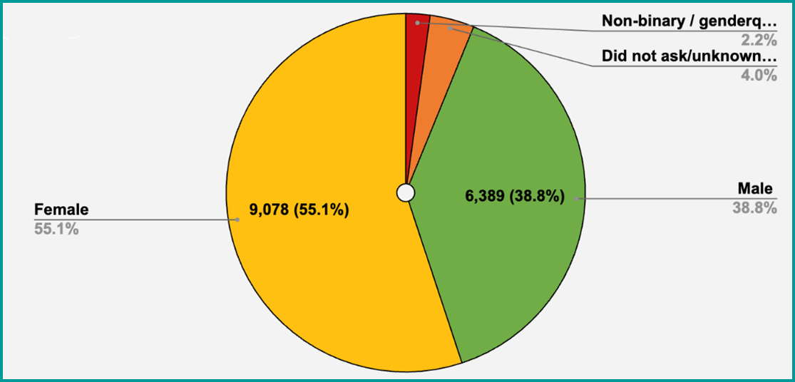4% were not asked or gender is unknown

*FY24 YouthReach participants by gender*

### **High School Seniors & Alums of CYD**

* 770 high school seniors participated in CYD programs. (5% of the total young people)
* Of those seniors, 93% graduated high school.
* 48% of CYD organizations have programs that have a formal process offering support graduates and another 32% offer some support.
* 76% of seniors have plans to attend college or a technical school next year.
* 1% of seniors are entering the military.

### Pie chart showing breakdown of how YouthReach participants' identify their race and ethnicity: 36% Hispanic (5,920), 24% Black or African American (4015), 16% Caucasian (2,686), 8% Asian (1,319), 1% Middle Eastern (114), 7% Multi-racial (1163), 7% are of “unknown race” (1092) **Race & Ethnicity**

*FY24 YouthReach participants by race and ethnicity*

## Other Aspects of the CYD Population

Some characteristics of the young people engaged in these CYD programs include:

* 51% live in economically depressed urban environments (8,468)
* 40% face neighborhood violence (6,587)
* 20% live in a home a where English is not the primary language spoken. (3,306)
* 16% have disabilities (2,556)
* 13% live in public housing (2,095)
* 7% are foreign-born youth (1,074)
* 5% are Department of Mental Health clients (784)
* 3% live economically depressed rural environment (487)
* 2% are Department of Children and Families clients (309)
* 1% are Department of Youth Services clients (146)

Organizations also reported that of 19% (3,189) young people had additional challenges other than those listed above.

## Demographic Changes Between 2023 & 2024

While organizations increased their overall numbers, the demographics remained quite similar to last year. Exceptions include:

* 2% increase serving young people who face neighborhood violence
* 3% decrease of youth living in public housing
* 10% decrease for youth living in economically depressed urban areas
* General increase of engagement with young people with disabilities

**Increase in the number of young people per year:** Compared to the numbers in the beginning of our three-year YouthReach cycle in FY21, the number of youth participants has more than doubled – from **8072** in FY21 to **16,484** youth participants in FY24.

**Increase in the average total number of young people per organization:** The average of the total number of young people across organizations increased from **112** per organization in FY21 to **194** in FY24.

## Overview of FY24 Narrative Findings (based on 85 reports)

### **Needs & Risk Factors**

*“We have seen mental health needs rise among young people in our community since the COVID pandemic; and food insecurity and housing insecurity continue to be critically pressing issues faced across our city. We have contracted with a trained social worker who has vast experience working with young people in Chelsea to offer our team support and guidance as we navigate these challenges.”* - **Green Roots**

Organizations spoke to a wide net of interlocking needs that have continued past the pandemic. When asked at the end of FY24 (June 30, 2024), “***What did your organization see that you were compelled to better understand and address****? (Please check the top four needs and comment on what you have witnessed.)”*

Of 85 organization reporting **the greatest issues** that their organization needed to take time to address this year were very similar to FY23 with some notable increases:

* 89% Mental Health
* 64% Transportation
* 54% Recruitment
* 40% Food Insecurity
* 39% Staff retention
* 28% Technology
* 26% Housing Insecurity

**Cross-sector issues that came up this year were primarily in the intersections of:**

1. **Mental health** and behavioral health
2. Lack of accessible and reliable **transportation**
3. Stress from **recruitment and retention** of staff and young people
4. **Food insecurity**/financial instability and families in stress

### **Addressing Risk Factors**

We explore these four issues below along with the ways that CYD organizations have attempted to work to address these issues.

#### 1. The Issue of Mental Health

This year **89%** of our85 CYD programs in Massachusetts identified **Mental Health** **at the top of the four greatest issues** (compared with **86%** in FY23). For the past four years that we have tracked this trend, it has consistently remained as a top concern. In FY24, organizations maintained their momentum of responding to mental health needs by forming partnerships to support young people, and to support and train staff so that they could create stronger programs to meet these needs. They continued to speak of the long-standing nature of the mental health crisis but remarked with increased concern for how young people’s consistent necessity to have access to technology may be deeply affecting youth mental health and socialization.

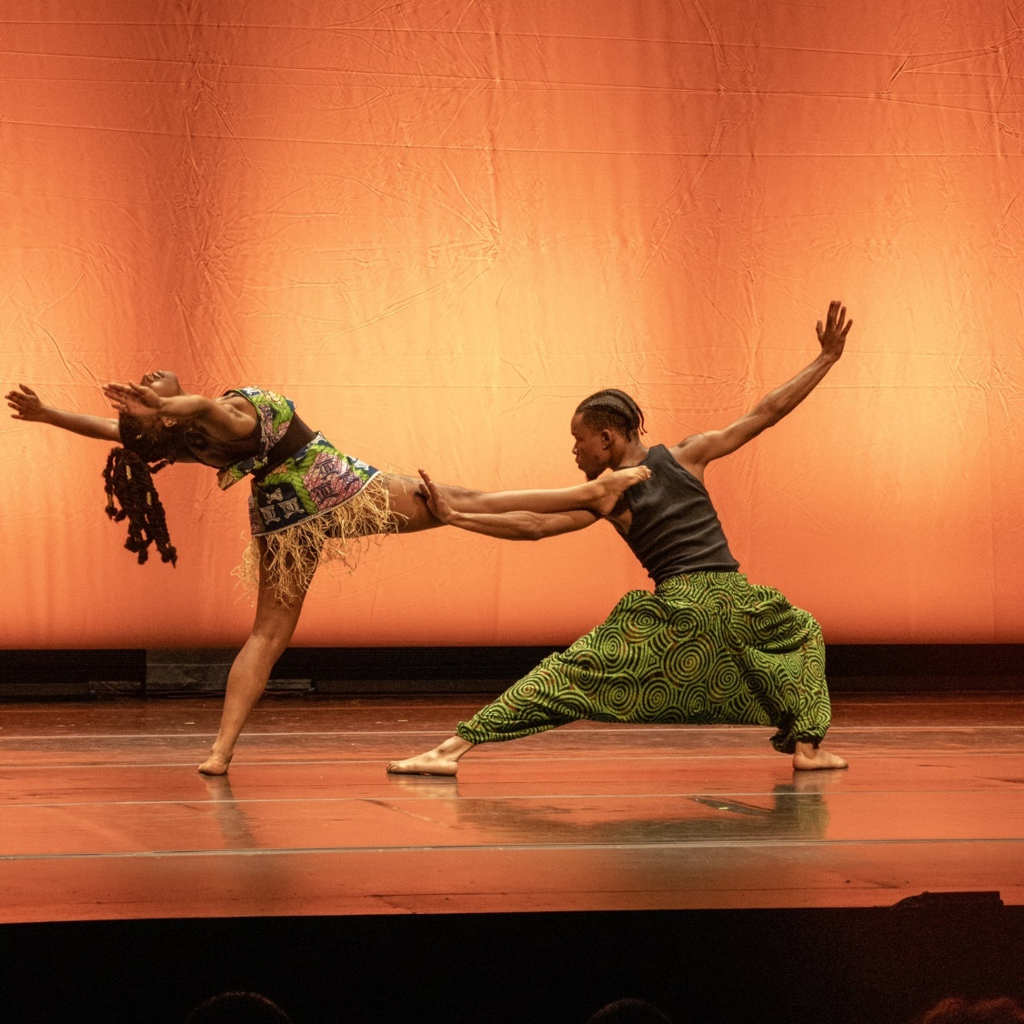Often the challenges of mental health, recruitment, and retention came as a package. Many noted that retaining staff had been difficult because staff who support young people often have increasingly found that they themselves need support. Although they continued to speak about being under-resourced, many organizations sought support through the building of thoughtful curriculums as well as forming partnerships with other youth-serving non- profits.

Taalib Dibinga-Robinson and Zanyah Dorfeuille performing Umoja Wa Afrika at the annual Twist & Shout gala to benefit the OrigiNation Cultural Arts Center. Photo: PhotosByDrizzy.

*“We provided support by offering additional workshops and creating a safe space where students felt comfortable sharing their feelings. We also leveraged our extensive network of school counselors, therapists, and social workers to assist our students and their families in accessing the help they needed. Additionally, we instituted free days where students could come to the studio to sit with their thoughts or simply be around their friends.”* - **Origination**

CYD Solutions to Addressing the Issue of Mental Health

The Creative Youth Development field is, and always has been, very resourceful and able to build community. In an environment of limited budgets and staffing, the 85 organizations continued to report on the monumental challenges in mental health for young people in their programs and but also how they have worked especially hard this year to address these many challenges. A significant investment from organizations went into funding partnerships to include social workers to be part of their staff. Also noted were the importance of trainings for Teaching Artists and front-facing program staff to help them recognize symptoms of mental health issues and give them tools to respond appropriately.

*“Recognizing the increased mental health challenges post-pandemic, we expanded our team of social workers to three full-time professionals. This allowed us to provide more comprehensive social-emotional support, fostering personal and social identity development among our students. Our efforts in this area have helped students build stronger connections with themselves and their peers, promoting mutual learning and healing.” -* **Bridge Boston**

In FY24, suggestions included:

* **Develop flexible schedules and check-ins for young people.** Young people with complex needs were offered access to counseling, connection to case management, and support to their families as needed. Organizations reported needing to “slow things down within our programs, so that we could tend to relationships, build trust, and address the complexities that young people and their families were dealing with.”
* **Participate in and design Trauma Informed Care Trainings for staff, mentors, and young people.** Many examples include how they have received further Trauma informed training and have formed strong partnerships with behavioral health. This year more reported hiring licensed social workers, therapists, and art therapists as well as connecting further with school wraparound coordinators and counselors. Through these investments staff members were able to receive supervision (with specific scenarios that they were navigating) and identify approaches they could take to working with young people with trauma.
* **Create special and specific strategies and programs.** Organizations revamped their programs and designed more comprehensive social-emotional curriculums with enhanced coping skill strategies that intertwined directly into their programs.
* **Bolster partnerships with Community Health Centers and hospitals.** Many organizations sought to re-establish these cross-sector relationships, disrupted during COVID-19 as well as finding the importance in establishing new ones. This included being able to connect with on-call mental health specialists.

Two specific examples:

1. The organization **Arts In Recovery for Youth** reported an increased retention and satisfaction rate with their program that included, “teaching DBT skills and suicide prevention to youth and their families using an arts-based approach. Referring and collaborating with providers of higher-level care or specialized care such as the Teen Intensive Outpatient Program, the Adult Partial Hospitalization Program, Community Behavioral Healthcare, individual mental health clinicians for therapy.”
2. The**Cambridge Community Center** indicated great success in hiring a Director of Mental Health who led initiatives aimed at addressing the mental health needs of their participants. They reported that this position has been instrumental “in integrating social-emotional learning (SEL) into our programs, providing workshops, one-on-one counseling sessions, and peer support groups. Additionally, we collaborated with local mental health organizations to offer resources and referrals for participants and their families. This holistic approach ensures that our young people receive the emotional support they need to thrive both personally and academically.”

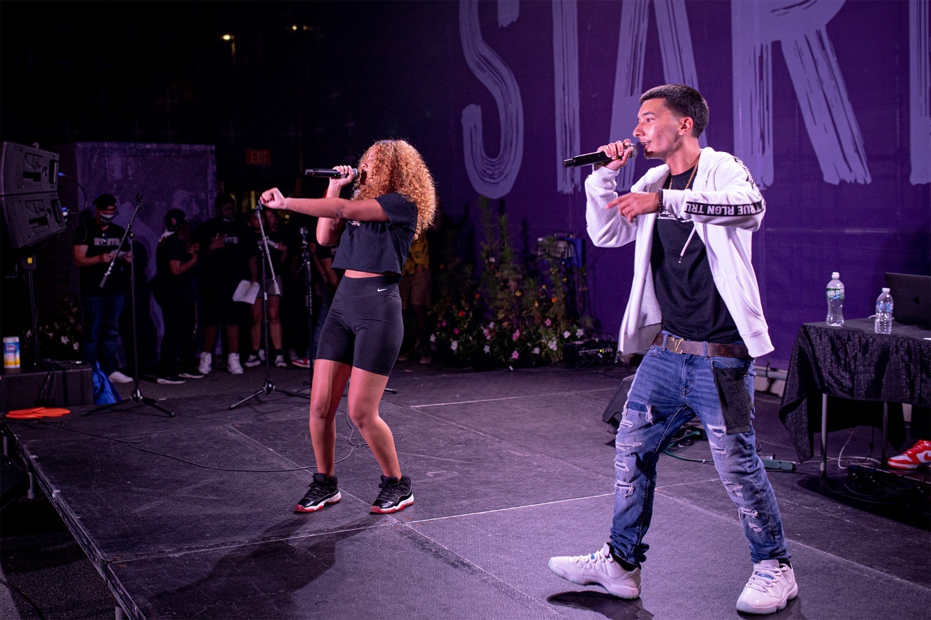

Anaijah and Max Performing at the Community Art Center’s summer showcase at Starlight in Cambridge, Photo: Burt Photography.

**Solutions Still Needed:**

Although organizations have reported heroic efforts and success, the need still far outstrips the services they can resource and the challenges they see ahead. They site high clinician turnover, long wait-lists for care, and lack of representation among health-care. Many wish to provide services themselves or to be able to partner with BIPOC-centered agencies that accept Medicaid. Furthermore, as political, social, and racial tensions continue or increase, so will the need. True Colors at **The Theater Offensive** offers insight:

*“Nearly 1 in 3 LGBTQ young people said their mental health was poor due to anti-LGBTQ policies and legislation. At The Theater Offensive (TTO), we are seeing a direct connection between the increase in hate on the national scale and the decline of mental wellness amongst QTPOC youth. To support youth mental health and social emotional learning, TTO has integrated a drama arts therapist and a healthy relationship consultant into our True Colors curriculum.”*

#### 2. The Issue of Transportation

Rising sharply from 52% in FY23 to 64% FY24, our CYD organizations identified Transportation as a major issue.

Discussion points included the barriers around:

* **Organizations in urban areas noted a significant increase in MBTA difficulties.** These included construction, delays, and inconsistency of the trains and busses. Getting to and from CYD program in a consistent manner proved extra challenging this year due to long unreliable commutes and the increased expense to get there.
* **Rural youth were particularly affected** because of minimal transportation options. Organizations in rural environments reported needing to provide young people with rides to and from home and the program.
* **The shortage of school bus drivers** both in rural and urban environments, making it so that schools were no longer able to drop off kids at the organizations. For some, the length of commute proved too long for young people to attend at the organization.

**CYD Solutions to Address the Issue of Transportation**

* Paying for ridesharing services (Uber/Lyft)
* Providing transportation stipends
* Organizing ride shares, volunteers, and staff to drive to increase enrollment
* Offering remote or virtual lessons
* Offering programming in the school day or after-school on site at the school

Two specific examples:

* From the **Flying Cloud Institute**: ***“****Transportation**remains a significant barrier for youth in the Berkshires and helps perpetuate the education opportunity gap that exists for youth in Pittsfield and rural south county. We have increased the number of community service partners we work with this year so that we can bring programs directly to youth and do not expect youth to come find us.”*
* From **Urbano:** *“Students are facing long commutes and are dependent on public transportation, which is unreliable, expensive and sometimes unsafe. Students often struggle with coming to class, and we offer a travel stipend to help ease some of the burden of commuting.”*

**Solutions Still Needed:**

Many report the desire for funding that would help mitigate the issues of transportation. **Ballet Rox** noted, *“More students and families would be able to participate if they had better transportation options… Funding for afterschool transportation from public schools to our program would greatly increase participation.”*

#### 3. The Issues of Recruitment & Retention

*“Our Tour Choir program, which is the most demanding and highest performing of our groups, has experienced a 30% drop in membership. Much of that reduction was due to high school graduation, families moving, or teens being able to take advantage of different afterschool activities during the pandemic since in-person singing was forbidden.” -* **Boston City Singers**

Compared to 59% in FY23, CYD organizations still identified recruitment as a major issue although they reported a slight decrease to 54% in FY24.

Many reported a recruitment and retention issue due to:

* Young people needing to financially support struggling families.
* Young people feeling over-committed, over-whelmed, and had competing activities
* The increased need to continue to expand and diversify recruitment strategies for reaching new participants, especially since “increased social anxiety has made tabling in school lunchrooms (to attract new participants) less effective.”
* Families changing residences due to gentrification (making it difficult for young people to attend).

Although what we are describing is largely about recruitment of young people, the rise and the increased concerns about staff recruitment and retention also seem to be quite connected to this issue. Organization continued to speak about the challenge of not only recruiting young people but also recruiting and retaining teaching artists, staff, and volunteers. As classrooms have experienced increased disruptions and rise in mental health challenges, organizations report challenges of burn-out among staff.

**CYD Solutions to the Issues of Recruitment & Retention**

Organizations continued to mention benefits of hiring staff and dedicating hours to directly attend to the issues of recruitment and retention. Particularly, they have focused on:

* **Utilizing methods of outreach**, including effective social media by involving young people.
* **Hiring a diverse staff** to better align with the demographics of the young people and their communities and who speak another language besides English.
* **Paying young people** to attend and better designing programming to match needs of the young people and their communities.

Two specific examples:

* From **Ballet Rox**: *“We introduced new recruitment strategies, including organizing free community events and dance workshops, which led to a significant increase in sign-ups, interest forms, and registrations. … and effectively employed social media strategies to further expand our audience.”*
* **Boston Children’s Chorus** wrote, *“To strengthen engagement, we made a deep commitment to equity as we built back from pandemic-era remote programming. We have accelerated engagement with children from Boston's most under-resourced neighborhoods by growing our partnerships, offering more in-school programs, and expanding our rehearsal locations across Boston neighborhoods.”*

**Solutions Still Needed:**

Several organizations wrote about how it has been increasingly difficult to retain contract teaching artists due to artists' need to look for full-time work, often going to other cities to find it. Reasons included:

* Staff must live further out to find affordable housing, and commutes become untenable.
* Organizations struggle to maintain multiple residencies running at once and find that relying on the same artists again and again can contribute to further burnout.
* Others reported that staff are retiring. Staff members who have been with the organization for more than 10 years plan to step aside within these next couple of years. Noted is the concern of their vast institutional knowledge and connections that will not be easy to replace.

To better enable teaching artists to stay with organizations, organizations have reported prioritizing paying higher competitive wages, giving signing bonuses, including work-from-home options, offering multi-year employment contracts, as well as to showcasing meaningful opportunities for career advancement.

**The Community Art Center** (CAC) summed it up well, *“We recognize that we are nothing if not for a committed, gifted, empathetic, artistic, generous, and invested staff. They give a lot of themselves to the work; and it can feel overwhelming at times.”* Therefore, CAC worked to develop an *“organizational culture that is highly-sensitive to burnout and regularly discusses ways in which to mitigate this”* which has also included increases in salaries.

#### 4. The Issue of Food Insecurity

Many of our CYD organizations serve low- and moderate-income households where young people may not regularly have access to nutritious and healthy food. This year, 40% of our CYD organizations identified Food Insecurity as a major concern (this concern showed an increase from FY23 when it was at 36%.)

Organizations describe the concern and increase in young people’s request for food.

* Many report that this insecurity has increased due to the increase in housing prices, financial instability, and lack of wage increases – all of which have left families struggling.
* **Artist for Humanity** reported that 75% of their young people reported their top spending category was food.
* Organizations report that they have seen both an increase in young people arriving to their programs hungry and asking to take additional food home.

**CYD Solutions to the Issue of Food Insecurity**

* **Many organizations have increased their food budgets** to provide healthy snacks and meals for young people. Some also mentioned providing extra food, “to make sure everyone got enough and had some to take home with them if necessary.”
* **Organizations have begun to grow** their own vegetables, set up food pantries, and connected young people and families to other food pantries and cross-sector services.
* **Organization have bolstered their partnerships** with schools in collaborating to provide healthy food for young people before the program begins and to send the young people home with not only food but also needed hygiene and sanitary supplies.

Two specific examples:

* **Raw Art Works** addresses food insecurity by providing meals for their college/career readiness program that extends after 5pm. They also have partnered with local chefs to develop life skills workshops focused on cooking.
* **Boys & Girls Club of Greater Lowell** started a new initiative called “Club Love on Meals” engaging teens ages 14-18 who reside in low to moderate-income households in culinary workforce training. The young people learn to organize and run the Club Love food truck distributing free food to young people in five Lowell neighborhoods and connecting other youth to the Club’s programs and availability of full dinners each evening**.**

**Solutions Still Needed:**

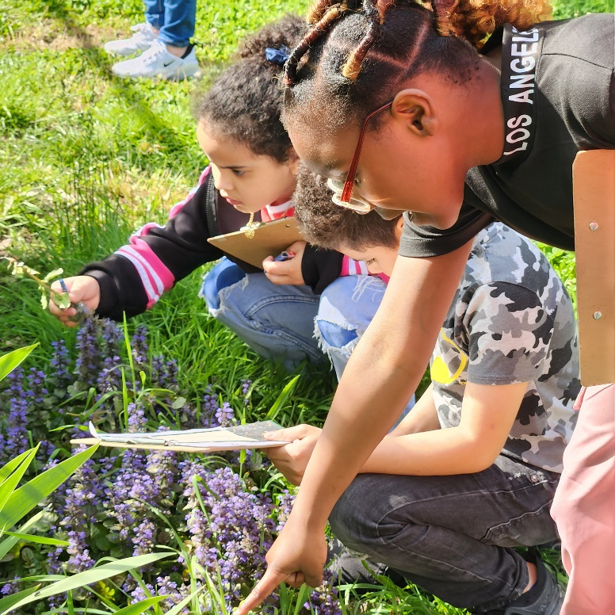Organizations see the connections to intersecting economic issues, housing needs, and the need for increased partnerships. To address these connections, it requires organizations to work with other community organizations to advocate for solutions for these complex problems. For example, the **Asian Community Development Corporation** (ACDC) spoke about young people also being directly involved in the understanding, solving, and advocacy for solutions. ACDC youth conducted community interviews, surveys, and research, and organized a free community event to educate Malden residents about the life cycle of food and food insecurity resources. They also partnered with Malden Arts, the Mystic River Watershed Association, and Friends of the Malden River, who tabled at the event to share their programs and services.

Students at Murkland Elementary School collect observational data for their schoolyard as part of a BioBlitz. Photo: Mass Audubon.

## Accomplishments

We have organized the highlights and accomplishments of FY24 YouthReach Report through the lens of the same three outcome areas reported on from our CYD organizations. These areas, identified by the [National Partnership for Creative Youth Development](https://www.creativeyouthdevelopment.org/cyd-outcome-areas/) in 2020, are simplified as **Create, Connect, and Catalyze**. In addition to these outcome areas, the focus of each area is also aligned with the 2023,[YAIN Indicators and Outcomes](https://docs.google.com/document/d/1LsKov71n9LZdwq2ZOCbxIDe2i_3Ec96ka2l1T_O4Tiw/edit?usp=sharing) and the Hewlett 2021 Report, Ten Dimensions of Powerful Arts Education.

Accomplishments centering all outcomes were also clearly seen in surveys - both in their qualitative and quantitative data. One example: “Roots Rising has had an impact on my life. I learned responsibility, how to be more independent, and also that I don't have to go through hard things alone.” After working at Roots Rising in 2023: 97% of the young people in ‘Youth Crew’ felt less sad, anxious or lonely.94% had more pride in their community. 84% reported that they had a stronger work ethic and 100% felt more prepared for the workforce.”

## Outcome 1

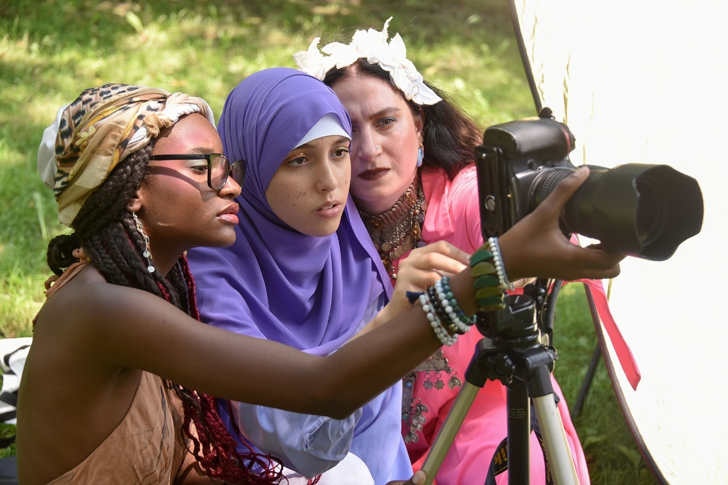**Create: Centering creativity, craft, youth voice, and storytelling**

Elio School of Fine and Applied Arts’ Teen Bridge Artist in Residence (AIR) Fellows with AIR Feda Eid during the summer, 2023 Intensive. Photo: Craig Bailey/Perspective Photo.

Organizations worked with young people to:

* **Strengthen their artistic voice**

*“Our dance team engaged in creativity, voice, and storytelling by preparing and performing various dance styles such as Cumbia, Salsa, Plena, Bachata, Bomba, and African Dance. They also delved into Modern Dance techniques and Hip Hop and Afro-Beats choreography, further showcasing their creative and artistic skills.” -* **Hyde Square Task Force**

* **Express themselves and communicate their own personal and collective concerns, confidence, and dreams**

*“Simply put, poetry builds confidence, which creates resilience. By exposing young mothers to renowned poets, and primarily BIPOC writers, the Poetry Project allowed students to see their own comparable experiences and perspectives reflected. They also gained a greater awareness of others' experiences and viewpoints and developed a sense of their own place within a broader human context. They wrote and published their own poetry, adding new voices as historically under served and marginalized women, enriching the field of poetry and becoming part of the public dialogue.” -* **Community Adolescent Resource and Education Center**

* **Support them in having access to high-quality tools and creative experiences**

*“As students grow, their increased motor skills and spatial understanding allow for more artistic expression. We emphasize using the entire body to convey their voice through dance.” -* **Ballet Rox**

## Outcome 2

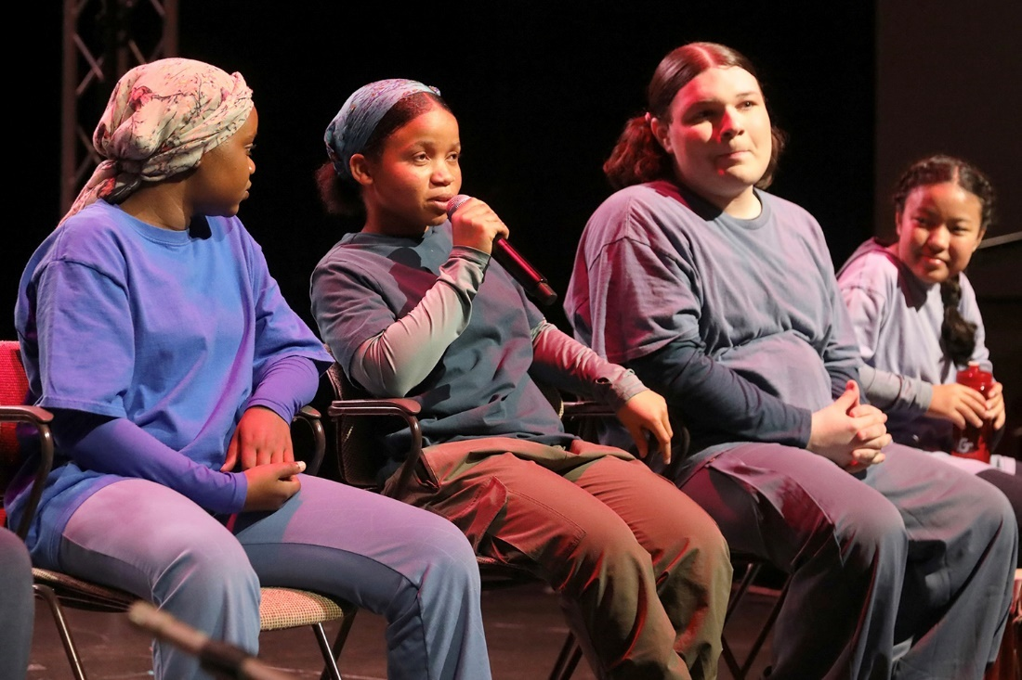**Connect: Focusing on self-discovery, healing, connection, collaboration, and mutual learning**

First Generation Ensemble of the Performance Project, facilitate a post-show dialogue. Photo: Ed Cohen.

In 2023-2024, organizations joined with young people to:

* **Co-create brave spaces for self-discovery, healing, creativity, and belonging**

*“First Gen is my second home, a place where I get to express my feelings and learn about other cultures, religions, and traditions. A place where I get to be myself and can say anything without being judged. When I need help, there is always someone here to help me and my family.” -* **Performance Project**

* **Discover and share their history, culture, and identities through the creative process.**

*“One transgender youth recently came up to me and showed me a graphic arts series where they illustrated themselves at different moments in their life (before, during and after their transition). Their creative process was clearly integral to their emerging self-expression, self-esteem and self-concept. This required a feeling of safety in the Brick House, and trust of staff and peers with whom they shared.”-* **Brick House**

* **Connect and collaborate - learning about self, others, and ways of seeing their world**

*“For me personally, poetry means being able to express myself and the way I view the world. Poetry is also a way to connect and learn and grow into not just better poets, but better people.”* In 2023-34, young people at Mass Poetry strongly agreed that “writing poetry is empowering to me,” and 70% reported that writing poetry boosts their mental health**.** - **Mass Poetry**

* **Engage with community members, organizations, and mentors, accepting support, guidance, and forming meaningful, diverse relationships and partnerships.**

*“Teams of young people at AFH created a three-minute animation for the Massachusetts General Hospital Department of Radiation Oncology. MGH has since requested a second animation and is exploring the potential for a whole series. This project was instrumental in providing a collaborative and educational experience, helping the youth to connect with themselves and their peers on a deeper level.” -* **Artists For Humanity**

## Outcome 3

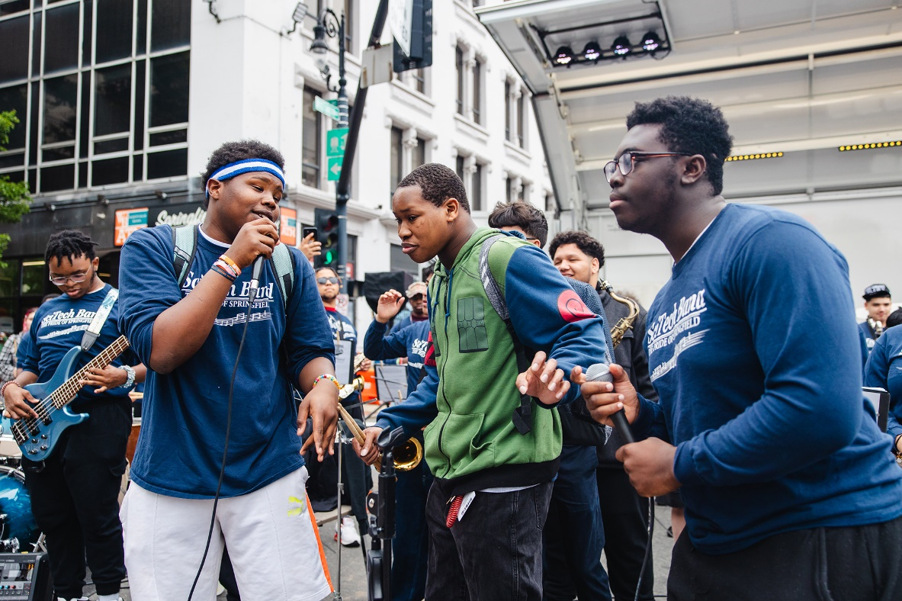**Catalyze: Cultivating leadership, collective action, and social justice**

Springfield Public Schools youth performance. Photo:Leon Nguyen.

Organizations reported the success of youth-led community building projects and events including advocacy for issues they care about.

Organizations collaborated with young people to:

* **Organize and design culminating events where they performed & presented their creations.**

*“...students catalyzed their creativity through three art gallery showcases, each marking the end of a trimester. They took ownership of the entire process, from creating the artwork to designing invitations, flyers, and programs. The students planned and hosted the gallery events, crafting a comprehensive and immersive gallery experience that culminated in a showcase exhibition night.” -* **YMCA of the North Shore**

* **Cultivate leadership through pathways, creative pursuits, and joining with others to shape their communities.**

*“One of the most significant accomplishments of FY24 was the success of our Junior Instructor Program, which empowered youth to take on leadership roles within the organization and their communities. Completing the three-year program, these young leaders are now paid Instructors at Gnome, and advocates for inclusion and accessibility in the broader community.” -* **Gnome Surf School**

*“The lack of youth spaces in Chelsea was an issue directly identified by our young people. The Youth Spaces Campaign is not only building youth power and leadership but catalyzing real change in our communities.” -* **Green Roots**

* **Explore diverse aspects of arts and culture opportunities with community partners.** This also included access to internships, fellowships, and other education opportunities.

*“Youth catalyzed change in their lives and communities through building leadership skills and presenting art with social justice themes. AIR Fellows received training on oral history from Boston Public Library and interviewed and photographed an influential person in their lives. They also curated, installed, and presented their own exhibition at Piano Craft Gallery and presented at two additional exhibitions of their work at the Boston Public Library.” -* **Eliot School of Fine and Applied Arts**

**Community School of Springfield** (CMSS) responded to requests from schools to provide additional music training, college readiness and workforce development opportunities. Young people were hired as interns and received acceptance letters to colleges for music. CMSS has effectively worked to supplement their training (college courses, gigging locally) to help support their success.

* **Meet with elected officials to present creative works for dialogue and change.**

*“True Colors youth performed at the Massachusetts Statehouse. This performance bolstered TTO’s connection with both state government official and the AmplifyGSA summit, while also providing the youth the opportunity to connect with and perform for community leaders.” -* **The Theater Offensive**

**Community Music Center of Boston** (CMCB) welcomed Mayor of Boston, Michelle Wu into their space with student performances and a roundtable discussion with five of our their youth leaders, *“Five youth employees sat down with Mayor Wu to discuss their experiences in Boston Public Schools and the role of arts in their lives, before turning to ask Mayor Wu questions about urban development and displacement, advice on leadership as a BIPOC woman, and city priorities on social justice and equality."*

* **Advocate for change through community initiatives with youth voice at the center**

*“On March 11th, SciTech had a school shooting. An armed person from outside the building forced their way into the building. Thankfully no one was shot. The school community was shaken. In response, our students led and performed at a unity rally for the school to bring healing…. Our student leaders demonstrated the power of student voice to inspire change.” -* **Springfield Public Schools**

*“La Colaborativa youth leaders wrote, produced, and staged two original, bilingual plays with young audiences in mind that they presented to a 200-person audience of local children and parents in Chelsea as well as facilitated interactive activities, arts and crafts, games, and delicious local food.”* They also worked with young people to explore narrative change and policy organizing through documentary filmmaking. *“Our youth participants were trained in technical aspects of filmmaking including script writing, cinematography basics, audio, and editing. Together, they produced four documentary shorts investigating the urgent need for affordable childcare in Chelsea, and the greater impact of the lack of accessible care. The youth researched, wrote, directed, and edited these projects and upon finishing them hosted a local film festival to share with the community. Through this initiative they were exposed to in-demand technical skills through hands-on film production and implemented film as viable medium for policy organizing and narrative change.” -* **La Collaborativa**

* **Take hold of opportunities for travel, seeing their creative impact beyond their own communities**

*“We brought two of our ClimaTeens to Capitol Hill Ocean Week in Washington D.C. as participants of Sea Youth Rise Up, a program that empowers and mobilizes youth to advocate for our ocean. Along with ten other youth delegates from across the world, they attended the CHOW conference, met with their representatives on the hill, met with Secretary of State J.R. Littlejohn of the Bureau of Oceans and International Environmental and Scientific Affairs, and met with the Council on Environmental Quality. The ClimaTeens left this experience with a strong appreciation for the impact that their own climate advocacy work can have on the world at large.” -* **New England Aquarium**

*“Two of our youth ensembles, Marmalade (jazz) and Porque Puma? (Latin) went to the Panama Jazz Festival in January 2024 where they performed for festival audiences, gave masterclasses, participated in workshops, and participated in larger ensembles for which they earned Berklee credit. This trip also gave our students a chance to connect with Central American Latino culture and network with artists from around the world.” -* **ZUMIX**

## Conclusions & Recommendations

The YouthReach FY24 final reports spoke to the deep and wide commitment that organizations have to their youth, families, and communities. They recognize the many interlocking needs and strive to address them. Engaging with young people, they help them create, connect, and catalyze change in their lives and are increasingly bolstering collective partnerships and collective action as valuable efforts both in FY23 and FY24. Organizations identified and addressed many challenges this past year for young people, especially surrounding their basic food needs, transportation, access to programs, and increased their focus on mental health.

*“In last year's report, we wrote about the intense mental health struggles we were witnessing in our teenagers post-Covid (increased anxiety, self-harm, and addiction to social media) and how/why we believed they were negatively impacting recruitment. Unfortunately, we have not yet seen marked improvement in those trends, but we HAVE been better able to address mental health for long-term participants. We value the depth of our programs (that is, working with a fairly small core of youth over several years rather than a large and rotating number each year), and when teaching artists have strong familiarity with a young person, it naturally translates to providing better supports.” -* **Actors’ Shakespeare Project**

In the recent Crisis Text Line report, it shows that through 87,000 anonymized conversations in the "[Crisis Text Line](https://urldefense.com/v3/__https:/www.crisistextline.org/wp-content/uploads/2024/02/community-resilience-brief.pdf__;!!CPANwP4y!UeRVtcexR6_IIyicRNVlUQt6xtjDpYHlx7c78KCundFjcwq_8f1Z2VCsQE-Ffa9Uy2IB6JBWFJyePyW3nxIzxvh6$)" the top two of six resources that youth in crisis say they need from their communities to help them cope are:

1. Opportunities for social connection.
2. Engagement in music, writing, visual, and performing arts.

YouthReach offers young people both. The arts can and do change lives when access and the ability to bridge differences is activated across the sectors and people find ways to advocate for change. Teaching artists have profound effect on our young people and greatly influence how we are able to develop a thriving, sustainable sector.

Recommendations for How Funders & Cross-Sector Partners Can Help

When we enlarge the breadth of the approaches to community-based care, we can show the variety of roles that arts/culture and Creative Youth Development can play as essential partners. However, we need creative strategies at the individual, organizational, and systemic levels with important partnerships in the philanthropic sector. In the new report and recent presentation, [*Thriving Together: Cultivating Well-being & Sustainability in the Social Sector*,](https://www.nonprofitpractice.org/wp-content/uploads/Thriving-Together-Cultivating-Well-being-and-Sustainability-in-the-Social-Sector.pdf) nonprofit leaders consistently list burnout as one of the top challenges affecting their organizations.

* Yearly employer costs due to stress-related absenteeism is $154 billion.
* U.S. nonprofits have lost over 1.5 million workers since the start of the pandemic.
* In Massachusetts, we have the extra challenge in that we also rate at 49th out of 50th of the states for cost of living (Bureau of Labor Statistics).

Furthermore, burnout has been significantly exacerbated in recent years especially when paired with increased workloads, low compensation, and the rise of staff in non-profits needing to attend to complex, mental health issues (which also can create secondary trauma in staff.) Although so much more than “workforce investments”, the more we can invest in teaching artists and their organizations, the more their skills, creativity, and care can help young people and their communities to thrive. Our CYD organizations are clear, that although they have been able to be very resourceful and provided transportation, food, and mental health services when access was limited, they need greater support. If we are to continue to retain our expert teaching artists in our chronically under-resourced sector, strategies that center well-being and equity for our sector are needed. Both the FY24 Final Reports of YouthReach and the [Thriving Together](https://www.nonprofitpractice.org/wp-content/uploads/Thriving-Together-Cultivating-Well-being-and-Sustainability-in-the-Social-Sector.pdf) study (looking at their Cohort-Based Approach) identified the importance of supporting networks, the investment in talent, and greater access to resources as ways to decrease burn-out. Similarly, we recommend the:

1. **Funding of networks and opportunities for convening** – Because networks within and across sectors create “a sense of community and psychological safety for leaders” and help to “proactively addressing burnout and stress,” networks and in person and virtual convenings should be a given greater priority for funding.
2. **Support of partnerships and trainings with behavioral and mental health providers.**  CYD organizations requested further access to essential tools and in-depth trainings in mental health with paths to certifications and further education**.** Support is needed for the further training of Teaching Artists (as Community Health Workers), increasing their access to supervisors, and in providing other resources to develop spaces for healing-centered engagement. This support will add assets to the behavioral health workforce and increase strategies for prevention.
3. **Development of platforms/tools/strategies to promote resources, professional development opportunities, trainings, incentives, and leadership pathways.** Greater communication is needed to promote cross-sector opportunities and paths for young people, alums, and teaching artists (adapting resources to fit these needs). This will also help organizations find ways to access resourcesfor transportation, food, and connections to better address Social Drivers of Health for young people and their families.
4. **Support of organizations to document and communicate their impact.** Through numbers, stories, and powerful photos, organizations may co-invest in tools, platforms, and common indicators, to find and report on the factors that influence well-being (see example of the 3C Data Alliance) With support, organizations will powerfully speak to the documented effectiveness of well-being practices in addressing well-being concerns, and the external impact of well-being for the young people they work with and the communities they serve.

Through these networks, trainings, resources, and increased value in well-being data, organizations will also be able to better advocate for arts and culture, young people, their creativity, and to catalyze systems change in these years ahead. Expanding pathways to care through low-barrier access points in our CYD organizations, will also allow CYD organizations in diverse communities, to amplify the understanding of the role that they play in addressing expansive needs and bolstering success in young people.

With support of the diversity, creativity, tenacity, and care in their well-earned roles as trusted messengers, our Creative Youth Development organizations will continue to co-develop ways to increase the skills, connection, and health and well-being of young people, along with their families and communities.

*"Our Wind Symphony performed a piece titled ’Fragile’, which was written to provide a soundscape of mental health. Many of our students had a deep connection with this piece, and enjoyed not only performing it, but also discussing its significance and personal connections during rehearsal.” -* ***Margarita Muñiz***

Margarita Muñiz Academy Foundation’s Spring Concert. Photo: Francisco Santos. 