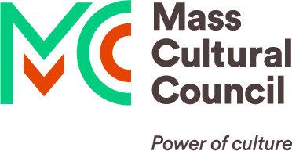

Card to Culture
Implementation GUIDE: how to get started

How it works – Card to Culture discount partnerships
Card to Culture makes cultural programming accessible to low-income families for whom cost is a participation barrier.
Organizations that run cultural programs can apply to participate by offering free or steeply discounted access to Massachusetts-issued EBT, WIC, and/or ConnectorCare health insurance cardholders and can:
- Set their own discount amount (if any) and the number of people allowed per card or household for each discount.
- Limit the number of spots available for discounted access if there is limited capacity for a class, performance, event, etc.
- Establish the policies, protocols, and processes for administering their discount.
- Choose which cards to accept.
  - Visitors use these cards to identify their discount eligibility only; the cards cannot be used for payment.
Organizations also receive training, communications, and policy support from the Mass Cultural Council. At the same time, the agencies administering these cards promote the participating organizations to their constituents.

Program guidelines
To be listed, organizations must have some cultural connection to the arts, humanities, or interpretive sciences within their programs. However, we use these terms broadly and welcome all applicants to apply if their access goals align with the program.
Proposed discounts must provide free or steeply discounted access to active and consistent programs in their entirety using accessible and equitable practices.
- Steep Discounts provide free access or at least a 50% discount to an organization's active/consistent programs.
  - Organizations whose programs are free are eligible to participate only if all their programming is entirely free and publicly available.
- Active Programs incorporate some level of activity. An outdoor mural/statue in a public space void of an engagement component (e.g., Artist Talk, etc.) would be ineligible since it is passive and static on its own.
- Consistent Programs have set or planned scheduling (e.g., weekly, monthly, annually, etc.), or other continuity. Ad hoc programs (i.e., programs that will run "if funding allows") are excluded.
- Entirety means every performance or event within your series or seasonal program or every class or workshop within your curriculum or semester.
  - Exceptions can include fundraisers, non-self-presented works, and events put on by performing groups that rent your venue.
- Accessible Practices means your discounts are available and applicable:
  - During all normal operating hours.
  - To the family or individual adult holding the accepted card. (i.e., do not require that the cardholder be present).
  - Published Instructions: Any instructions patrons must follow to receive your discount should be clearly stated on your website (see website requirements below).
- Equitable Practices include policies and protocols for Card to Culture patrons that are consistent with how you treat the rest of your patrons. Examples include:
  - Photo ID: Do not ask Card to Culture patrons to see a photo ID in addition to their EBT, WIC, or ConnectorCare card.
  - Payment Methods: If other discounted patrons can purchase tickets via cash or credit card, Card to Culture patrons should not be required to pay by cash only.
  - At the Door Only: If other discounted patrons can buy tickets once they are available for purchase, Card to Culture patrons should not be limited to buying tickets at the door on the day of an event.
  - Online Discount Codes: If other discounted patrons (e.g., students, seniors, etc.) can purchase tickets using online discount codes, Card to Culture patrons should also be able to purchase their discounted tickets online.

Participation requirements – organizations consent to the following:
- Duration: Honor your offered discount(s) from the time of sign-up through the end of the calendar.
  - Organizations do not need to reapply each year. Instead, their applications are automatically renewed unless they respond to the opt-out notification typically sent in late December.
- Listing(s): Have your discount(s) and visitation information listed on our agency partners’ websites and applicable promotional materials.
- Website: Publish your discount offer and any instructions patrons must follow to receive it. Reference and link to the Card to Culture program, its agency partners, and the complete lists of participating organizations.
  - Please note that “approved” applicants must fulfill the website requirement before they can be added to the list of participating organizations. Applications will be considered withdrawn if this step is not completed within 30 days of applying and no communication has been made.
- Staff Training: Train box office or admissions staff ahead of implementing your Card to Culture discount(s) to make the overall patron experience as smooth and welcoming as possible.
- Final Report: Keep track of the total number of discounts you applied separately by each card type you accept, and report that data to the Mass Cultural Council annually (generally due in January or February for the previous year).
  - Failure to submit final reports can result in being removed from the list(s) of participating organizations.

Adding Card to Culture to your website
Please note that once applications are approved, organizations will need to fulfill the website requirement to be added to the list of participating organizations. However, applications will be considered withdrawn if this step is not completed within 30 days of applying and no communication has been made.
Applications will revert and remain in "Request Revisions" status until the organization’s website is updated as follows:
- Add your Card to Culture discount offer text and any instructions patrons must follow to receive it.
- Reference and link to the Card to Culture program, its agency partners, and their complete lists of participating organizations.

As an example, you can incorporate the above as follows:
“We are proud to participate in Mass Cultural Council's Card to Culture program in collaboration with the Department of Transitional Assistance, the Department of Public Health's WIC Nutrition Program, the Massachusetts Health Connector, and hundreds of cultural organizations across Massachusetts by expanding cultural access for low-income and working families.
EBT, WIC, and ConnectorCare [whichever your organization accepts] cardholders [add your discount text. If necessary, include any instructions/policies cardholders should follow or pertinent information they should know such as restrictions about certain events or exhibits, cancelation policies, limited availability, etc.]. See the complete list of participating organizations offering EBT, WIC, and ConnectorCare discounts.”
There should be similar messaging wherever else you regularly advertise discounts. Below are the complete URLs to the above links, which is where your organization will be listed—once this step is complete—during the next batch of quarterly updates.
Mass Cultural Council administers the Card to Culture program, supporting participating organizations:
- https://massculturalcouncil.org/organizations/card-to-culture/
The Department of Transitional Assistance administers the Electronic Benefit Transfer (EBT) programs:
- https://www.mass.gov/ebt-card-to-culture
The Department of Public Health administers the Women, Infants & Children (WIC) Nutrition Program:
- https://www.mass.gov/info-details/get-discounts-with-your-wic-card
The Massachusetts Health Connector administers the ConnectorCare health insurance program (multiple carriers):
- https://mahealthconnector.org/connect-to-culture

Logos / visuals
There is no specific logo for the Card to Culture program. However, organizations can use the Mass Cultural Council logo and the logos of our agency partners. Augmenting these logos with "Card to Culture" text is prohibited!

Guidelines for using our logo can be found on our website:
https://massculturalcouncil.org/about/contracts/credit-logos/
It is also effective to use an image of the eligible cards as a visual indicator.

Electronic Benefit Transfer (EBT) cards (Valid through December 31, 2023):
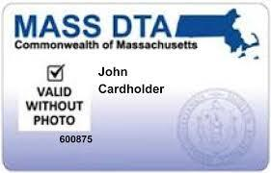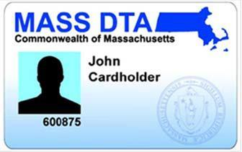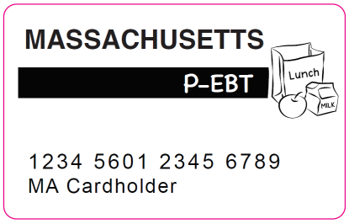
Do not use the “SNAP” logo, which implies the discount is only available to those receiving SNAP benefits. Do not use the “Quest” logo, which is only for retailers that accept EBT cash payments directly. (If you are interested in becoming authorized by the DTA to accept payment at your cafeteria or farmers market, email Greg Torrales for more information.)

Women, Infants, & Children (WIC) Nutrition Program card:

ConnectorCare health insurance cards (Valid through December 31, 2023):
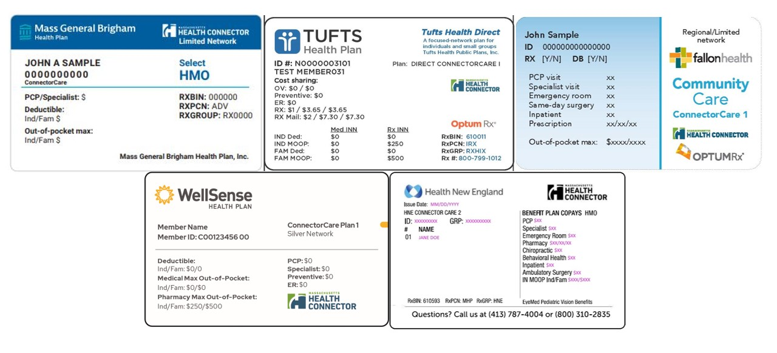
IMPORTANT: There are five (5) different ConnectorCare cards – one for each of the participating health insurance companies. Look for the label “ConnectorCare,” as not all health insurance plans administered through the Health Connector system are eligible.

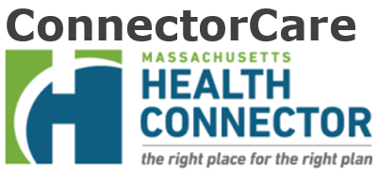
Instead of the cards above (which may confuse people with non-eligible plans), you may want to display this adapted version of the Massachusetts Health Connector logo, with “ConnectorCare” clearly stated:

General best practices for training staff
Live-Action Role Play
Some organizations train their staff through scenario-based Live-Action Role Play. Staff members can engage each other as patrons to practice talking about the Card to Culture program, your discount offering, and any protocols patrons would need to follow to receive the discount.
Supplement Existing Training Processes
Incorporate the Card to Culture Resources for Organizations within your existing training manuals, sessions, etc., that are related to administering your discount.
Make information about the program visible for your Front of House staff, so they are reminded about the program when patrons ask if they are eligible for any discounts.
Whenever a visitor asks what the cost of admission is, your staff should always include "and [__] for families with [EBT / WIC / ConnectorCare health insurance] cards.”
Training Webinars
The first 30 minutes of this Card to Culture Info Session introduces our agency partners and provides an overview of the programs they administer and the populations they serve. For additional insight, here are the links to each program’s eligibility criteria:
- Economic Assistance (TAFDC & EAEDC) programs,
- Food Assistance (SNAP & WIC) programs,
- And the ConnectorCare Health Insurance program.
This in-depth Card to Culture Training Webinar goes deeper into best practices for implementing procedures and daily operations.
The Creating Welcoming, Inclusive Spaces blogpost and webinar are primarily for front-of-house staff. DAEI Consultant, Sandra Bonnici, walks the audience through concepts, techniques, and best practices for creating welcoming and inclusive experiences for all visitors, especially those experiencing poverty.
There is also plenty of Card to Culture-adjacent training topics you can engage with your staff (e.g., ADA Compliance, Cultural Competency, Unconscious Bias, DEI, Accessibility, Anti-Poverty Shaming, etc.)

General best practices for promoting your Card to Culture participation
E-Newsletter
Include your Card to Culture participation within your e-newsletters. You can include it alongside any preexisting accessibility messaging, fundraising campaigns (see below), or your ticketing information.
Existing Marketing Collateral & Communication Channels
While there are Card to Culture fliers you can print and give to visitors who use this discount, we recommend adding 1-2 sentences to the existing marketing collateral you regularly distribute or give to visitors (e.g., flyers, posters, direct mailers, brochures, playbills, etc.) You can also include this in your e-newsletters (see above), social media campaigns (see below), and print and radio advertisements.
Fundraising
Allow your supporters to make donations on behalf of your Card to Culture participation to help offset participatory costs (e.g., Zeiterion). Your development teams can also leverage Card to Culture when applying to grant programs (e.g., Local Cultural Councils, Festivals & Projects, etc.). You can also include it within your annual donor letter.
Organizational Networks
Connect with Health & Human Service organizations to have them help get the word out about this program locally. By extension, these can also include local Public Schools and Libraries, Neighborhood Associations, Food Pantries, Public Housing Authorities and Independent Living Centers, Farmers' Markets, organizations that support immigrant families, individuals with disabilities, and senior citizens, and regional DTA Offices, SNAP Outreach Partners, WIC Offices, ConnectorCare Navigators, MassHealth Service Providers, and housing-related Service Providers.
Community Resources for Families: The Department of Early Education & Care has gathered resources from public schools, early intervention programs, Family Resource Centers, Coordinated Family and Community Engagement grantees, public libraries, community action agencies, and local boards of health into this interactive online tool.
Point-of-Sale Signage
Have signage of your Card to Culture discount(s) at your point-of-sale, admissions, registration areas, etc. Signage can include card images.
Press Releases
Announce your Card to Culture participation in a press release to send to your local community newspaper (and other media outlets) to amplify the message.
Social Media
When mentioning the program on social media, use the hashtags #PowerOfCulture and #CardToCulture. If you only have space for one hashtag, please use #PowerOfCulture. You can also tag the agency partners administering the program:
- Mass Cultural Council is @masscultural on Facebook, Twitter, and Instagram
- The Department of Transitional Assistance is @DTA_Listens on Twitter
- The WIC Nutrition Program is @MassWIC on Facebook, Twitter, and Instagram
- Massachusetts Health Connector is @HealthConnector on Facebook, Twitter, Instagram, and Threads
Website
In addition to where your main Card to Culture text resides on your website, add a few sentences on your other relevant web pages (e.g., on each event page).

General best practices for engaging new patrons
Bring A Friend
Offer new patrons comp tickets/guest passes to bring a friend. An adjacent strategy is facilitating ways to connect existing patrons with new visitors.
Pre-Show (Know Before You Go) & Post-Show (Thank You) Emails
Send new patrons a “Welcome” or “Know Before You Go” email. These can include links to subscribe to your e-newsletters and social media channels, requests for feedback, and FAQs for patrons visiting for the first time. Some organizations have ways of identifying new patrons to send them physical “thank you” cards afterward.
Provide a Personal Touch
Based on an organization’s discount protocols, some begin engaging new patrons when they call to reserve their tickets. These small yet impactful moments can help new patrons feel comfortable when attending your programs for the first time. After building rapport, you could mention your future concerts, free community programming (if any), and nearby organizations that also participate in Card to Culture.
Streamline Logistics
If your ticketing software allows, identify new Card to Culture patrons so that they don’t have to show their cards again after their first visit. Alternatively, you can have your box office/registration staff develop an internal process to accomplish this.

